**Debugging Task Test Report**

Tests

**NPC name bug –** the NPC name would not load correctly and printed a bunch of question marks at the end of NPC names. To fix this I needed to add 1 to the ‘nameSize’ variable and tell the program to ignore data in the array until it reaches a ‘nullptr’. This will ignore the extra data in the file and only print relevant information.

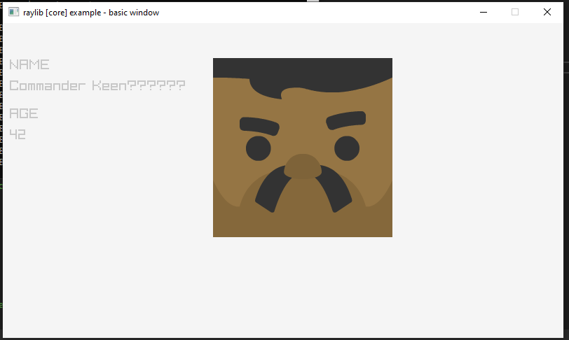

**Program crashing** – once you tab past the 5th record the program will crash, to fix this I changed the ‘currentRecordIdx’ to 0 when it goes past the 5th record, this resets to the first record. I also enabled the left key to toggle to the last record and circle around backwards.

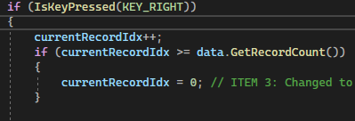

**Long Loading** – the program was originally reading the whole data file and storing the whole thing in memory which isn’t very efficient especially if there is lots of data in the file. To circumvent this, I implemented a random-access algorithm to jump straight to the required record. The program doesn’t save the file at all. When the user scrolls across the next NPC is loaded directly from the file. I use a for loop to check if I get the right index otherwise, I use ‘seekg’ to seek the correct position in the file. Once I have the correct position then I load the record details to the screen. More efficient than saving the whole file.

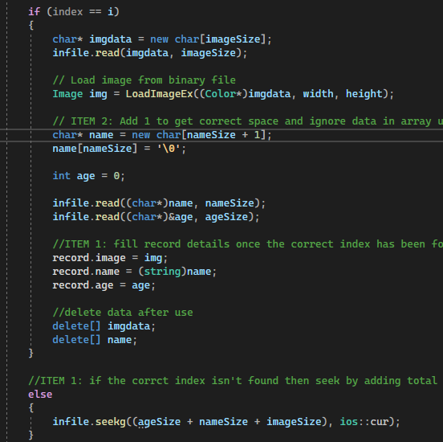

Debugging Screenshots

**Breakpoints**

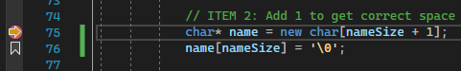

**Watch variables(auto and custom)**

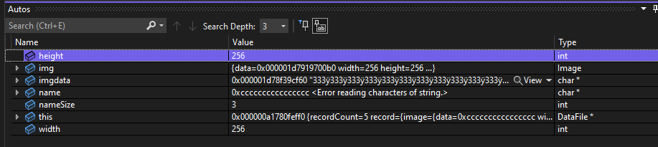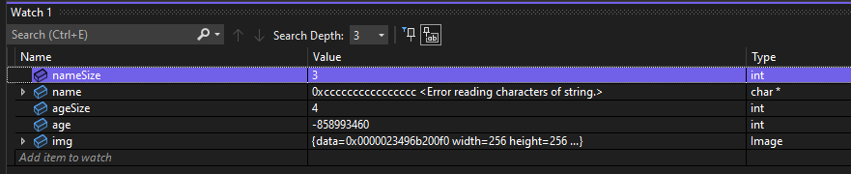

**Call Stack**

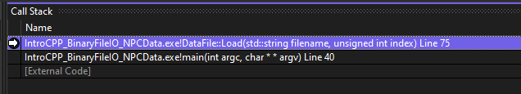

Keyboard Shortcuts

Stop Debugging – (Shift + F5)

Restart – (Ctrl + Shift + F5)

Step Into – (F11)

Step Over – (F10)

Step Out – (Shift + F11)